Meeting Minutes
Queen Mary Elementary School PAC Meeting
November 5, 2024 7:00 – 8.30 pm
Virtual

ATTENDANCE

Elise Hindle
Elyssa Derban
Heidi Nienaber
Kris Bobko
Laura Atkins
Natalia Kravchenko
Paulina Kung
Raymond Wong
Robin Atkins

Meeting

- Land Acknowledgement and Welcome (Robin)
- QM PAC Executive changes
- Natalia switches from DPAC rep to Secretary. DPAC rep role is vacant now.
- Motion to approve Agenda
- No modifications
- Robin moves
- Raymond seconds
- Motion carried, unanimous consent
- Motion to approve October PAC Meeting Minutes
- Robin moves
- Raymond seconds
- Motion carried, unanimous consent
- Principal report (Elyssa)
- FSAs are finished
- We had the drill with students release, it was important to practice
- Cross country season had last meet on Oct 22
- Parent-Teacher Conferences on October 22-23, great involvement, some teachers saw all the families
- Halloween parade was very fun
- Remembrance Day is going to be held on Nov 8, kids will lead
- Nov 14 – Immunization Clinic
- Nov 22 – Professional Day
- Dec 16 – Report Cards going home
- Treasurer’s report (Raymond)
- Balance is around $21000
- Outstanding and Committed funds are for Lice Screening, Christmas Song Along and Author Visit
- Screenager movie earned some money (around $110 cad)
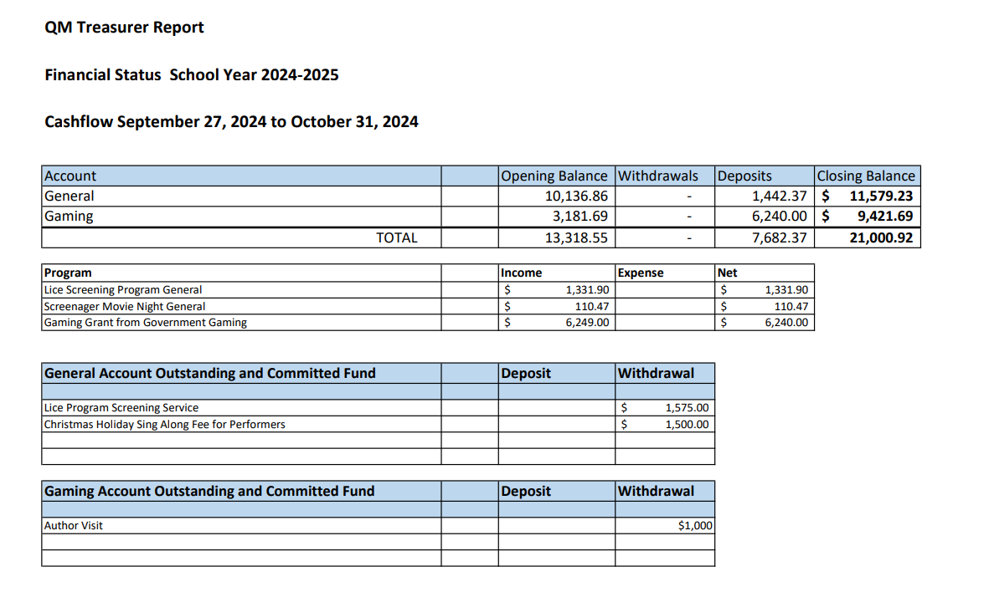
- PAC Report
  - Crossing guard program (Heidi)
- Very successful, 22 parents, 2 crossings covered so far
- Positive community feedback, people also want us to cover crossing at East Trimble and 6th
- Need more people. Every crosswalk needs 10 shifts (people). We cannot start new crosswalk until we have enough volunteers (East Trimble and 6th)
- Statistics on the crosswalks: 3 mornings + 3 afternoons we counted people. On average morning the walking traffic on East side takes 63%, on West side 19%. On average afternoon East side takes 67%, West side 13%. This is why we need to guard the East Side. We thought that we needed the West Side anyways because it was less safe. But it turns out the East side is heavily used and according to community feedback we need to guard it.
- All interested people are already volunteering.
- Elyssa plans to have a call with new recruits
- Robin suggests we could guard the East side instead of the West side. Heidi says it was Elyssa’s call to not abandon the West for the sake of consistency. We do not want to be inconsistent. It is the second most heavily used crossing and we want to redirect more people there.
- Elyssa asks about numbers. Heidi gives numbers (more than 100 people crossing East crosswalk), Elyssa suggests moving from West to East as there are so many people crossing at East.
- Laura asks about students, whether they will be doing crosswalk volunteer job. Heidi says not this year.
- Elyssa says there are now 6 speed bumps around the school
- Heidi tells about the training manual she developed
- Robin suggests requesting funding if Heidi needs it
- Heidi tells about bigger stop signs at a nearby school. But now volunteers are the priority
- Cris (School Officer) will give us more cones. Cones will hold signage and protect no stopping zones. Maybe we will need a wagon to bring cones.

  - Lice screening (Robin)
- 120 students tested, one of three tests is done

  - Growing Smiles (Raymond)
- Low participation (24 orders vs 80 – 110 last year). Deadline is extended to November 12. We need to spread the message
- Laura: will you have enough orders to cover the minimum? Raymond says he hopes to get more people on board
- Class parents might be the best source, but we do not have many class parents this year.
- Heidi: why there are not many class parents?
- Robin: some teachers have less need for class parents because of better email communication. Not all teachers think it is worth it.
- Elyssa: maybe we need to redefine the role of the class parent. Communication is easy for the teacher now. But this is the way to communicate PAC info to the parents. Low participation causes low attendance of after school programs.
- Elyssa suggests flyers that go to the backpack.
- Paulina suggests offering some catch for parents to step up; maybe there is some miscommunication so that not everyone knows about the possibility to become a class parent
- Robin suggests a possibility to sign up online + some incentive
- Heidi says her teacher does not need the class parent. Heidi thinks we need to find the way to find parents’ emails.
- Laura says that the teacher needs the class parent in preparation for winter fair, but there is no winter fair this year.
- Robin: who wants to volunteer to communicate and solicit class parents? Robin suggests help
- Elyssa: PAC could send home a notice to send back the contact information.
- Laura: printing is 150 dollars. Laura suggests combining the flyer for PAC and Growing Smiles
- Natalia: can we use teachers to reach people?
- Heidi, Paulina and Natalia say that people do not know about parent events
- For Growing Smiles we will do one last push to boost the sales

  - Library fundraiser (Robin)
- 26 books ordered
- Paulina: went to the website but was unsure how to make a purchase. Pauline suggests more detailed instructions.

  - Pac Coffee Morning (Nov 26, Cory)
- We need to spread the word
  - Author visits (Melissa)
- Funding is approved, we will be a bit over (under 200 cad), we will approve later

  - Screenagers
- Great success, 60 people attended
- Next show is on Feb 13

  - Handmade craft (Laura)
- Elyssa: Laura’s proposal to carry on tradition of crafts by donating money for crafts was discussed by teachers. Teachers were grateful, but teachers are worried about the goal of the craft and about the timing. Without class parents it also would add up the workload for teachers. We have to define the goal and think about the sustainable way.
- Heidi asks was it communicated about the need for the winter fair coordinator
- Laura told about how no one came forward in spite of the communication. Laura explained that it was a huge undertaking and looked like no one wanted to take over it.
- Heidi emphasizes the problem of communication

  - Ting suggested photo booth, Elyssa gives an update:
- There is a connection with the photographer who organizes the festive photo booth taking pictures with the backgrounds. They charge small fee from PAC and $10 cad for the picture per family.

  - Motion to approve up to 1000 funding for winter craft supplies from general account.
- Heidi makes a motion.
- Heidi does not support the idea of donating. Adding a Condition: kids must be able to bring crafts home
- Raymond seconds
- Motion carried, unanimous consent
- PAC Exec role (Robin)
- Robin and Laura move out QM at the end of the year
- Robin warns that PAC could be dissolved, and it is very hard to reinstate. We need 2 people to run PAC next year, and we need it in April
- Laura adds that if we do not move forward, we would have to donate everything and give our money away to ministry
- PAC Fair and Events that need Coordinators (Robin)
- Indoor movie nights and Multicultural Coordinators in February will not happen unless we have people for it.
- Heidi: we need more people to hear it
- Attracting people to PAC:
- Google form via teachers (to sign up for newsletter and sign up as class parent).
- Paper form that goes in backpack
- Robin will follow up with the google form
- Elyssa: pdf flyer can be printed in a district within two days
- Raymond can print the flyers as well
- Natalia, Elyssa and Robin will prepare the form, Elyssa will send it out

Next meeting is Tuesday Dec 10 at 7 – 8.30 pm virtually.

